Default Report  
*Remote Studies Affects*  
**March 19th 2022, 8:14 am MDT**

**Q_RecaptchaScore**

|  |  |  |  |  |  |  |  |
| --- | --- | --- | --- | --- | --- | --- | --- |
| # | Field | Minimum | Maximum | Mean | Std Deviation | Variance | Count |
| 1 | Q_RecaptchaScore | 0.80 | 1.00 | 0.92 | 0.07 | 0.00 | 40 |

**Q1 - How many semesters have you studied remotely?**

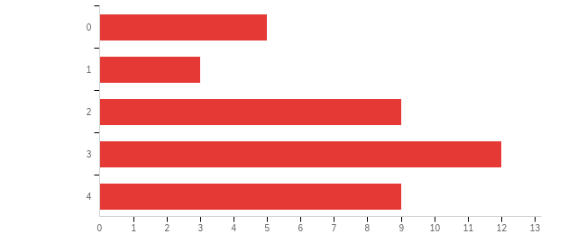

|  |  |  |  |
| --- | --- | --- | --- |
| # | Answer | % | Count |
| 1 | 0 | 13.16% | 5 |
| 2 | 1 | 7.89% | 3 |
| 3 | 2 | 23.68% | 9 |
| 4 | 3 | 31.58% | 12 |
| 5 | 4 | 23.68% | 9 |
|  | Total | 100% | 38 |

**Q2 - What is your preference in terms of instruction style?**

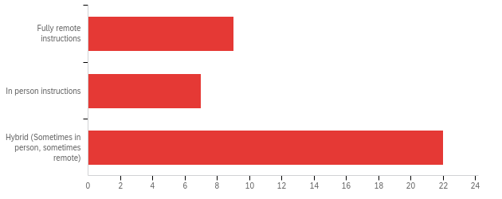

|  |  |  |  |  |  |  |  |
| --- | --- | --- | --- | --- | --- | --- | --- |
| # | Field | Minimum | Maximum | Mean | Std Deviation | Variance | Count |
| 1 | What is your preference in terms of instruction style? | 1.00 | 3.00 | 2.34 | 0.84 | 0.70 | 38 |

|  |  |  |  |
| --- | --- | --- | --- |
| # | Answer | % | Count |
| 1 | Fully remote instructions | 23.68% | 9 |
| 2 | In person instructions | 18.42% | 7 |
| 3 | Hybrid (Sometimes in person, sometimes remote) | 57.89% | 22 |
|  | Total | 100% | 38 |

**Q3 - What's your preference in terms of exams**

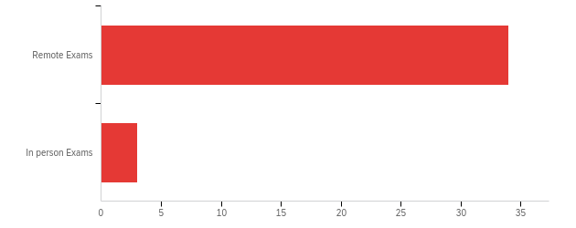

|  |  |  |  |  |  |  |  |
| --- | --- | --- | --- | --- | --- | --- | --- |
| # | Field | Minimum | Maximum | Mean | Std Deviation | Variance | Count |
| 1 | What's your preference in terms of exams | 1.00 | 3.00 | 1.13 | 0.41 | 0.17 | 38 |

|  |  |  |  |
| --- | --- | --- | --- |
| # | Answer | % | Count |
| 1 | Remote Exams | 91.89% | 34 |
| 2 | In person Exams | 8.11% | 3 |
|  | Total | 100% | 37 |

**Q4 - What's your preference in terms of synchronous?**

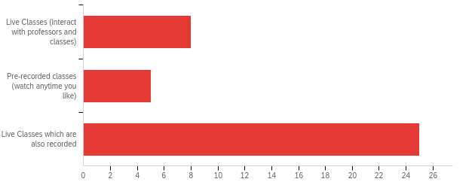

|  |  |  |  |  |  |  |  |
| --- | --- | --- | --- | --- | --- | --- | --- |
| # | Field | Minimum | Maximum | Mean | Std Deviation | Variance | Count |
| 1 | What's your preference in terms of synchronous? | 1.00 | 3.00 | 2.45 | 0.82 | 0.67 | 38 |

|  |  |  |  |
| --- | --- | --- | --- |
| # | Answer | % | Count |
| 1 | Live Classes (interact with professors and classes) | 21.05% | 8 |
| 2 | Pre-recorded classes (watch anytime you like) | 13.16% | 5 |
| 3 | Live Classes which are also recorded | 65.79% | 25 |
|  | Total | 100% | 38 |

**Q5 - Hours of sleep a day?**

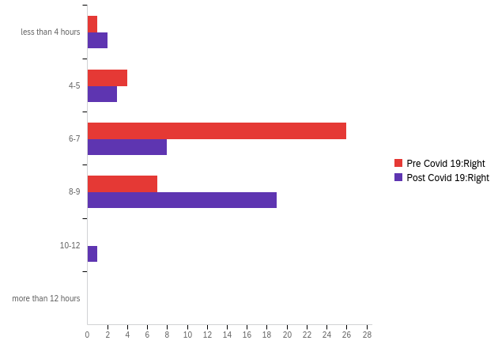

|  |  |  |  |  |  |  |  |  |  |  |  |  |  |  |
| --- | --- | --- | --- | --- | --- | --- | --- | --- | --- | --- | --- | --- | --- | --- |
| # | Question | less than 4 hours |  | 4-5 |  | 6-7 |  | 8-9 |  | 10-12 |  | more than 12 hours |  | Total |
| 1 | Pre Covid 19:Right | 2.63% | 1 | 10.53% | 4 | 68.42% | 26 | 18.42% | 7 | 0.00% | 0 | 0.00% | 0 | 38 |
| 2 | Post Covid 19:Right | 6.06% | 2 | 9.09% | 3 | 24.24% | 8 | 57.58% | 19 | 3.03% | 1 | 0.00% | 0 | 33 |

**Q6 - Hours of self study? (per day)**

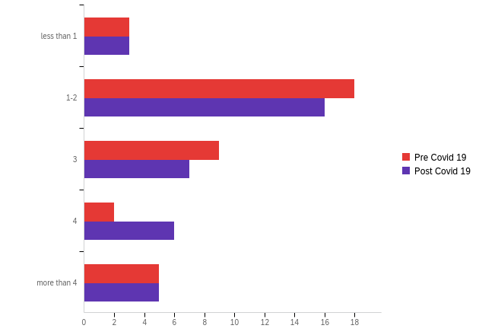

|  |  |  |  |  |  |  |  |
| --- | --- | --- | --- | --- | --- | --- | --- |
| # | Field | Minimum | Maximum | Mean | Std Deviation | Variance | Count |
| 1 | Pre Covid 19 | 1.00 | 5.00 | 2.68 | 1.14 | 1.30 | 37 |
| 2 | Post Covid 19 | 1.00 | 5.00 | 2.84 | 1.20 | 1.43 | 37 |

|  |  |  |  |  |  |  |  |  |  |  |  |  |
| --- | --- | --- | --- | --- | --- | --- | --- | --- | --- | --- | --- | --- |
| # | Question | less than 1 |  | 1-2 |  | 3 |  | 4 |  | more than 4 |  | Total |
| 1 | Pre Covid 19 | 8.11% | 3 | 48.65% | 18 | 24.32% | 9 | 5.41% | 2 | 13.51% | 5 | 37 |
| 2 | Post Covid 19 | 8.11% | 3 | 43.24% | 16 | 18.92% | 7 | 16.22% | 6 | 13.51% | 5 | 37 |

**Q7 - Hours of self-care a day? (Sports and Hobbies)**

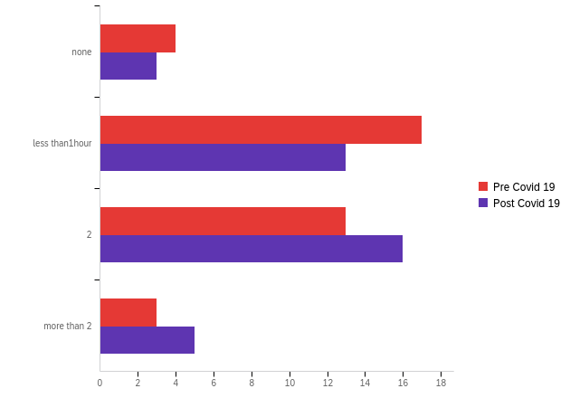

|  |  |  |  |  |  |  |  |
| --- | --- | --- | --- | --- | --- | --- | --- |
| # | Field | Minimum | Maximum | Mean | Std Deviation | Variance | Count |
| 1 | Pre Covid 19 | 1.00 | 4.00 | 2.41 | 0.79 | 0.62 | 37 |
| 2 | Post Covid 19 | 1.00 | 4.00 | 2.62 | 0.82 | 0.67 | 37 |

|  |  |  |  |  |  |  |  |  |  |  |
| --- | --- | --- | --- | --- | --- | --- | --- | --- | --- | --- |
| # | Question | none |  | less than1hour |  | 2 |  | more than 2 |  | Total |
| 1 | Pre Covid 19 | 10.81% | 4 | 45.95% | 17 | 35.14% | 13 | 8.11% | 3 | 37 |
| 2 | Post Covid 19 | 8.11% | 3 | 35.14% | 13 | 43.24% | 16 | 13.51% | 5 | 37 |

**Q8 - How has your overall GPA changed?**

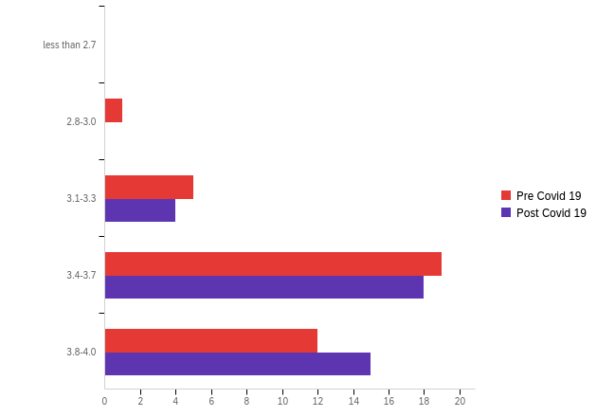

|  |  |  |  |  |  |  |  |
| --- | --- | --- | --- | --- | --- | --- | --- |
| # | Field | Minimum | Maximum | Mean | Std Deviation | Variance | Count |
| 1 | Pre Covid 19 | 2.00 | 5.00 | 4.14 | 0.74 | 0.55 | 37 |
| 2 | Post Covid 19 | 3.00 | 5.00 | 4.30 | 0.65 | 0.43 | 37 |

|  |  |  |  |  |  |  |  |  |  |  |  |  |
| --- | --- | --- | --- | --- | --- | --- | --- | --- | --- | --- | --- | --- |
| # | Question | less than 2.7 |  | 2.8-3.0 |  | 3.1-3.3 |  | 3.4-3.7 |  | 3.8-4.0 |  | Total |
| 1 | Pre Covid 19 | 0.00% | 0 | 2.70% | 1 | 13.51% | 5 | 51.35% | 19 | 32.43% | 12 | 37 |
| 2 | Post Covid 19 | 0.00% | 0 | 0.00% | 0 | 10.81% | 4 | 48.65% | 18 | 40.54% | 15 | 37 |

**Q9 - Daily commute to University?**

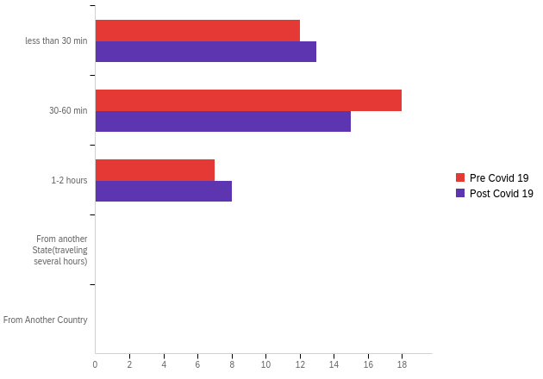

|  |  |  |  |  |  |  |  |
| --- | --- | --- | --- | --- | --- | --- | --- |
| # | Field | Minimum | Maximum | Mean | Std Deviation | Variance | Count |
| 1 | Pre Covid 19 | 1.00 | 3.00 | 1.86 | 0.70 | 0.50 | 37 |
| 2 | Post Covid 19 | 1.00 | 3.00 | 1.86 | 0.75 | 0.56 | 36 |

|  |  |  |  |  |  |  |  |  |  |  |  |  |
| --- | --- | --- | --- | --- | --- | --- | --- | --- | --- | --- | --- | --- |
| # | Question | less than 30 min |  | 30-60 min |  | 1-2 hours |  | From another State(traveling several hours) |  | From Another Country |  | Total |
| 1 | Pre Covid 19 | 32.43% | 12 | 48.65% | 18 | 18.92% | 7 | 0.00% | 0 | 0.00% | 0 | 37 |
| 2 | Post Covid 19 | 36.11% | 13 | 41.67% | 15 | 22.22% | 8 | 0.00% | 0 | 0.00% | 0 | 36 |

**Q10 - Access to Technology**

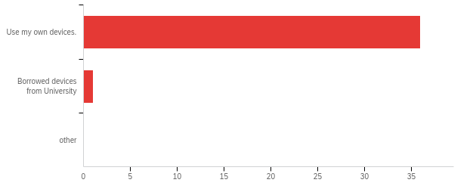

|  |  |  |  |  |  |  |  |
| --- | --- | --- | --- | --- | --- | --- | --- |
| # | Field | Minimum | Maximum | Mean | Std Deviation | Variance | Count |
| 1 | Access to Technology | 1.00 | 2.00 | 1.03 | 0.16 | 0.03 | 37 |

|  |  |  |  |
| --- | --- | --- | --- |
| # | Answer | % | Count |
| 1 | Use my own devices. | 97.30% | 36 |
| 2 | Borrowed devices from University | 2.70% | 1 |
| 3 | other | 0.00% | 0 |
|  | Total | 100% | 37 |